Pac-Poly-Marquesas-Cook-Print-1778

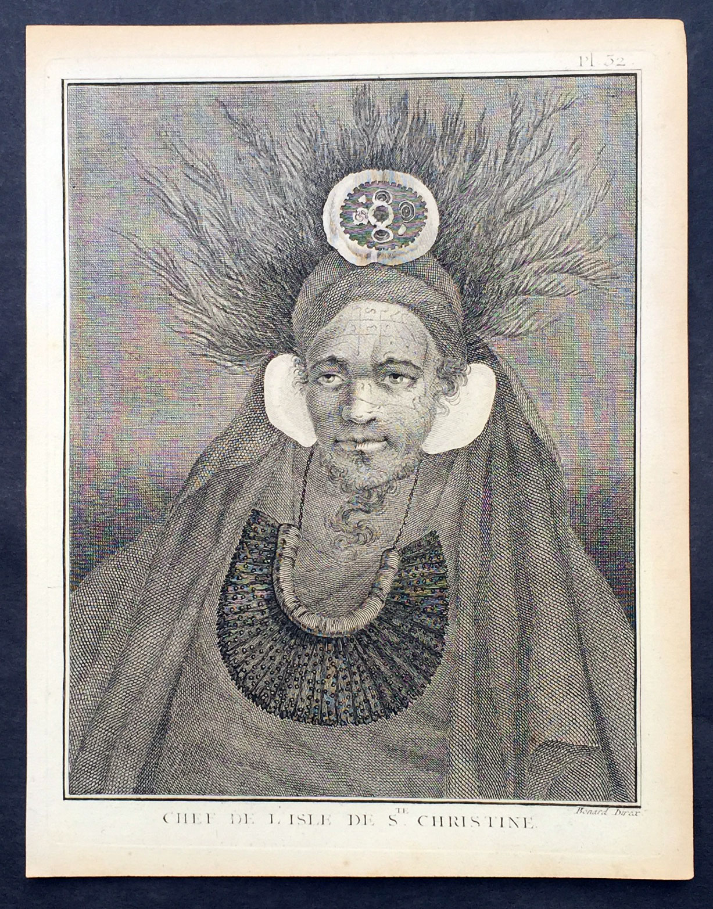

This fine original copper-plate engraved antique print, a portrait of Chief of Tahuata Island, Santa Cristina, in the Marquesas Islands, South Pacific, visited by Captain James Cook during his 2nd Voyage of Discovery in the South Seas in 1774, was engraved by Robert Benard - after William Hodges - and was published in the 1778 French edition of Capt. James Cooks 2nd Voyage of Discovery to the South Seas A voyage towards the South Pole, and round the World. Performed in His Majestys ships the Resolution and Adventure, in the years 1772, 1773, 1774, and 1775..... Paris : Hotel de Thou ......1778  
  
Cook Diary (1774)  
Apr. 7 Thu. Sights Hood’s Island (Fatu Huku), St. Pedro (Motare). La Dominica (Hiva Oa), St. Christina (Tahuata).  
Apr 8 Fri. Sails along southern coast of Hiva Oa looking for anchorage. Anchors in Resolution (formerly Madre de Dios) Bay (Vaitahu Bay). Canoes arrive, gifts are exchanged. Natives killed after an iron stanchion is stolen.  
Apr 9 Sat. Goes ashore, gifts exchanged, food obtained.  
Apr 10 Sun. Goes ashore to south end of Bay and visits house of dead man. Gifts exchanged.  
Apr 11 Mon. Goes ashore to south, again. Finds trade becoming expensive because of lavish gifts by his “gentlemen”.  
Apr 12 Tue. Sails towards St. Dominica. No anchorage visible. Heads SW away from islands.  
Apr 13 Wed. Sights last of the five main islands, Magdalena (Fatu Hiva).

General Definitions:  
Paper thickness and quality: - Heavy and stable  
Paper color : - off white  
Age of map color: -  
Colors used: -  
General color appearance: -  
Paper size: - 10in x 8in (255mm x 205mm)  
Plate size: - 9 1/2in x 7 1/4in (240mm x 185mm)  
Margins: - Min 1/2in (12mm)

Imperfections:  
Margins: - Light soiling in margins  
Plate area: - None  
Verso: - None

Background:   
Tahuata is the smallest of the inhabited Marquesas Islands, in French Polynesia, an overseas territory of France in the Pacific Ocean.  
The first recorded sighting by Europeans was by the Spanish expedition of Álvaro de Mandaña on 22 July 1595. They charted the island as Santa Cristina. They landed at Vaitahu that they named Madre de Dios (Gods Mother in Spanish). According to the Spanish accounts Tahuata had fowls, fish, sugar cane, plantains, nuts and fruits. The existent town was built on two sides of a rectangular space, the houses being of timber and intertwined canes. A building which the Spaniards supposed to be a religious one stood outside the town, in a space enclosed by palisades, and containing some ill-carved images before which were offerings and provisions. The people had large and well constructed sailing canoes. Their tools were made of shells and fish bones. They used slings, stones, and lances as weapons.  
Tahuata was visited by Captain James Cook in 1774 and Admiral Dupetit-Thouars in 1842, who signed the treaty annexing the Marquesas Islands to France.  
  
The Marquesas Islands are a group of volcanic islands in French Polynesia, an overseas collective of France in the southern Pacific Ocean.  
The first Europeans to reach the Marquesas may have been the crew of San Lesmes, a Spanish vessel which disappeared in a storm in June 1526; it was part of an expedition headed by García Jofre de Loaísa. The Spanish explorer Álvaro de Mendaña reached them seventy years later on 21 July 1595. He named them after his patron, García Hurtado de Mendoza, 5th Marquis of Cañete (Spanish: Marqués de Cañete), who served as Viceroy of Peru from 1590 to 1596. |Mendaña visited first Fatu Hiva and then Tahuata before continuing on to the Solomon Islands. His expedition charted the four southernmost Marquesas as Magdalena (Fatu Hiva), Dominica (Hiva ʻOa), San Pedro (Moho Tani), and Santa Cristina (Tahuata).  
In the late 16th century European explorers estimated the population at more than 100,000. Europeans and Americans were impressed with how easy life appeared to be in the islands, which had a rich habitat and environment. In 1791 the American maritime fur trader Joseph Ingraham first visited the northern Marquesas while commanding the brig Hope. He named them the Washington Islands. In 1813 Commodore David Porter claimed Nuku Hiva for the United States, but the United States Congress never ratified that claim.  
In 1842 France conducted a successful military operation on behalf of the native chief Iotete, who claimed he was king of the whole island of Tahuata. The government laid claim to the whole group and established a settlement on Nuku Hiva. That settlement was abandoned in 1857, but France re-established control over the group in 1870. It later incorporated the Marquesas into French Polynesia.  
  
William Hodges RA 1744 – 1797 was an English painter. He was a member of James Cooks second voyage to the Pacific Ocean, and is best known for the sketches and paintings of locations he visited on that voyage, including Table Bay, Tahiti, Easter Island, and the Antarctic.  
Between 1772 and 1775 Hodges accompanied James Cook to the Pacific as the expeditions artist. Many of his sketches and wash paintings were adapted as engravings in the original published edition of Cooks journals from the voyage.  
Most of the large-scale landscape oil paintings from his Pacific travels for which Hodges is best known were finished after his return to London; he received a salary from the Admiralty for the purposes of completing them. These paintings depicted a stronger light and shadow than had been usual in European landscape tradition. Contemporary art critics complained that his use of light and colour contrasts gave his paintings a rough and unfinished appearance.  
Hodges also produced many valuable portrait sketches of Pacific islanders and scenes from the voyage involving members of the expedition..  
  
Robert Bénard 1734 – 1777 was an 18th-century French engraver.  
Specialized in the technique of engraving, Robert Ménard is mainly famous for having supplied a significant amount of plates (at least 1,800) to the Encyclopédie by Diderot & d\'Alembert from 1751.  
Later, publisher Charles-Joseph Panckoucke reused many of his productions to illustrate the works of his catalog.

Cook , Capt. James 1728-1779  
James Cook was born on 27 October 1728 in Marton, England. His father was a poor farm labourer who had worked his way up to Overseer. James began as a farm labourer and grocer\\\\\\\'s assistant. He soon found employment on the Baltic sea in a Collier (coal transport ship) at the age of 18.  
During the war with the French in 1755, James Cook enlisted as an Able Seaman on the Eagle. Within a month he was promoted, because of outstanding ability, to Masters Mate. Four years later he was promoted to Master. In command of his own ship, James Cook performed a crucial charting of the St. Lawrence River, which made possible the great amphibious assault upon Quebec City in 1759. In 1763 he was given command of the schooner Grenville to survey the eastern coasts of Canada over a four year period. These excellent charts were used up until the early part of the 20th century.  
James Cook was selected to lead a 1768 expedition to observe the transit of Venus, and to explore new lands in the Pacific Ocean. In his first Pacific voyage, James Cook rounded Cape Horn in the Endeavour and reached Tahiti on 3 June 1769. After recovering a necessary scientific instrument stolen by the natives, the transit of Venus was successfully observed. The Endeavour then spent six months charting New Zealand. James Cook next explored and claimed possession of eastern Australia. Returning to England, on 12 June 1771, via New Guinea, Java and the Cape of Good Hope, the crew suffered an appalling 43% fatality rate. James Cook thus became very concerned about crew health on subsequent voyages. He instituted compulsory dietary reforms that were copied by many other ship captains.  
The object of Captain Cook\\\\\\\'s second Pacific Ocean voyage was to confirm the existence of a theorized Great Southern Continent. His ship the Resolution, accompanied by the Adventure, departed Plymouth on 13 July 1772 and sailed around the Cape of Good Hope. Beset by ice, he was unable to reach Antarctica. Although its existence was suspected, James Cook demonstrated, by traversing large areas of the south Pacific, that it would have to be a frigid wasteland, and not an economically productive addition to the British empire. James Cook charted many of the South Pacific islands with the incredible accuracy of 3 miles. This accuracy was made possible by a new and highly accurate clock. The two ships returned to England, via Cape Horn, on 29 July 1775. The experimental diets and close attention to cleanliness had a miraculous effect: out of a crew of 118, only one man was lost to disease! Since public interest was high, the many paintings by the artists were widely displayed and published as engravings. James Cook was also awarded the Copley Gold Medal and elected as a fellow of the Royal Society.  
The third great voyage is especially significant to the history of the west coast of North America. Captain Cook and his men were primarily searching for the Northwest Passage from the Pacific Ocean to the Atlantic Ocean. They departed Plymouth on 12 July 1776 in the Resolution and the Discovery.  
The ships sailed around the Cape of Good Hope to reach the west coast of America in February of 1778. They continued north along the coast in haste to the Bering Sea and Bering Strait in an attempt to pass through the Arctic Ocean during the summer season. Foiled by ice, James Cook returned to Hawaii to prepare for another attempt at the Northwest Passage the next season. Soon after they had departed, a storm damaged the foremast of the Resolution and forced a return to Kealakekua Bay for repairs. Unfortunately, they had previously overstayed their welcome and relations became tense. The theft of a ship\\\\\\\'s cutter led Captain Cook to put ashore to demand the return of the boat. A fight broke out and James Cook was killed on 14 Feb 1779 by angry natives. Although his men made another attempt at the Northwest Passage, they were unsuccessful. The expedition did identify the possibilities of trade with the coastal American natives for otter seal furs, which could then be bartered for Chinese goods that were highly prized in England.  
  
Cooks First Voyage (1768-1771)  
The first voyage under Captain James Cook\\\\\\\'s command was primarily of a scientific nature. The expedition on the Endeavour initially sailed to Tahiti to observe the transit of the planet Venus in order to calculate the earth\\\\\\\'s distance from the sun. Cook landed on the South Pacific island in April of 1769 and in June of that year the astronomical observations were successfully completed. In addition to these labors, very good relations with the Tahitians were maintained and the naturalists Joseph Banks and Daniel C. Solander conducted extensive ethnological and botanical research.  
Another purpose of the voyage was to explore the South Seas to determine if an inhabitable continent existed in the mid-latitudes of the Southern Hemisphere. Upon leaving Tahiti, Cook named and charted the Society Islands and then continued southwest to New Zealand. His circumnavigation and exploration of that country also resulted in a detailed survey. Cook proceeded to Australia, where he charted the eastern coast for 2,000 miles, naming the area New South Wales. As a result of these surveys, both Australia and New Zealand were annexed by Great Britain. In addition to these explorations, the Endeavour returned to England without a single death from scurvy among its men, an historic feat at the time. The combination of these accomplishments brought Cook prominence, promotion, and the opportunity to lead further expeditions.  
  
Cooks Second Voyage (1772-1775)  
Based on the success of his first voyage, Cook was appointed by the Admiralty to lead a second expedition. Two ships were employed with Cook commanding the Resolution and Captain Tobias Furneaux in charge of the Adventure. The purpose was to circumnavigate the globe as far south as possible to confirm the location of a southern continent. Cook proved that there was no Terra Australis, which supposedly was located between New Zealand and South America. Cook was convinced, however, that there was land beyond the southern ice fields. In his pursuit of this idea, this expedition was the first European voyage to cross the Antarctic Circle. In addition, in two great sweeps through the Southern latitudes, Cook made an incredible number of landfalls including New Zealand, Easter Island, the Marquesas, Tahiti and the Society Islands, the Tonga Islands, the New Hebrides, New Caledonia, and a number of smaller islands.  
In addition to these navigational accomplishments and the accompanying expansion of geographical knowledge, the expedition also recorded a vast amount of information regarding the Pacific islands and peoples, proved the value of the chronometer as an instrument for calculating longitude, and improved techniques for preventing scurvy.  
  
Cooks Third Voyage (1776-1779)  
In the course of his first two voyages, Cook circumnavigated the globe twice, sailed extensively into the Antarctic, and charted coastlines from Newfoundland to New Zealand. Following these achievements, Cooks third voyage was organized to seek an efficient route from England to southern and eastern Asia that would not entail rounding the Cape of Good Hope. The search for such a Northwest (or Northeast) Passage had been on the agenda of northern European mariners and merchants since the beginning of European expansion in the late fifteenth century. England\\\\\\\'s growing economic and colonial interests in India in the later eighteenth century provided the stimulus for the latest exploration for this route.  
Cook, again in command of the Resolution, was to approach the Northwest Passage from the Pacific accompanied by a second ship, the Discovery, captained by Charles Clerke. The ships left England separately, regrouped at Cape Town, and continued on to Tasmania, New Zealand, and Tahiti. The expedition then sailed north and made landfall at Christmas Island and the Hawaiian Islands. Cook continued northward and charted the west coast of North America from Northern California as far as the Bering Strait. He returned to Hawaii for the winter and was killed in a skirmish with natives on February 14, 1779. Upon Cooks death, Clerke took command of the expedition but died six months later. The ships returned to England in 1780 under John Gore, who had commanded the Discovery after Cooks death. From start to finish, the voyage had lasted more than four years. (Ref Tooley; M&B; Clancy)